Press Release
Grant Assistance for Grassroots Human Security Projects FY 2023:
Completion Ceremony for the Project for Building Resilience to Wildfires in Tsaghkadzor
Yerevan: June 4th, 2025
On June 4th, 2025, the Completion Ceremony for the Grant Assistance for Grassroots Human Security Project "The Project for Building Resilience to Wildfires in Tsaghkadzor" (grant up to: USD 72,915) was held at Meghradzor Wildfire Rescue Center. The ceremony was attended by Mr. AOKI Yutaka, Ambassador of Japan to Armenia, Ms. Anna Baghdasaryan, the Director of the Economic Journalists Club NGO, Mr. Kamo Tsutsulyan, Deputy Minister of Internal Affairs of RA, Mr. Aharon Sahakyan, the Governor of Kotayk region , Mr. Davit Nersisyan, the President of Armenian Red Cross Association along with administrative staff and project stakeholders.
This project aims to construct a volunteer fire station in Meghrazor Village, Tsakhkadzor City, Kotayk Region, thereby reducing the fire brigade response time from the previous maximum of one hour to approximately 15 minutes during wildfire incidents, protecting the lives and livelihoods of approximately 9,000 residents, including 1,849 displaced persons from Nagorno-Karabakh. The number of wildfire incidents in the region has increased annually from 15 cases in 2020 to 23 cases in 2022, resulting in severe damage with a total of 453 hectares of forests, residential areas, and agricultural land destroyed by fire. Therefore, this project addresses the urgent challenge of ensuring regional residents' safety through establishing a rapid initial response system.
Ms. Baghdasaryan, Representative of the Economic Journalists Club, expressed her gratitude, stating, “Japan’s support in this region, which is prone to natural disasters such as forest fires, is extremely valuable to us. The newly constructed volunteer fire station is a crucial facility that will enable a faster initial response in times of disaster and help minimize damage. This support is also significant from the perspective of human security. We are committed to making full and effective use of this facility through the cooperation of the entire community.”

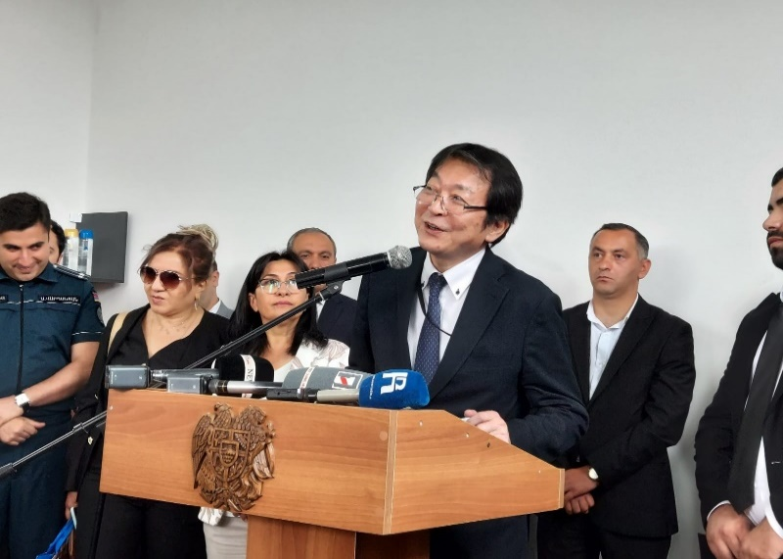 | 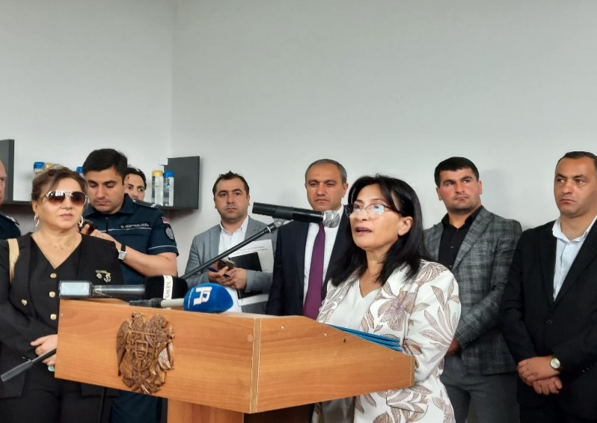  Photo #2
Ambassador Aoki giving congratulatory speech | Ms. Baghdasaryan expressed her gratitude to project Japan
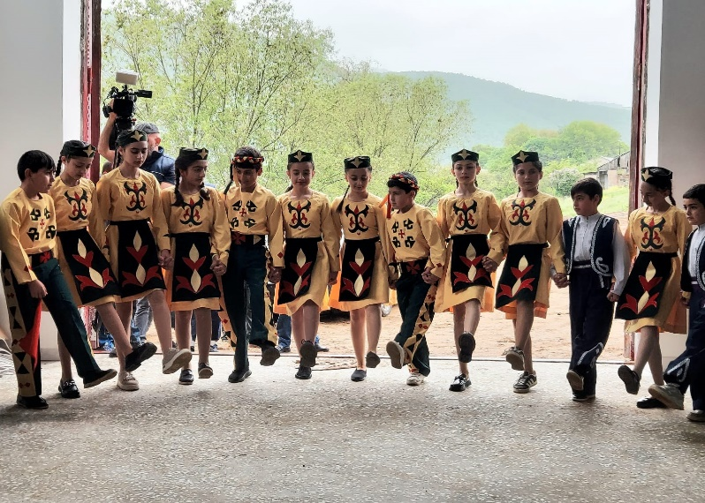  Photo #3 | 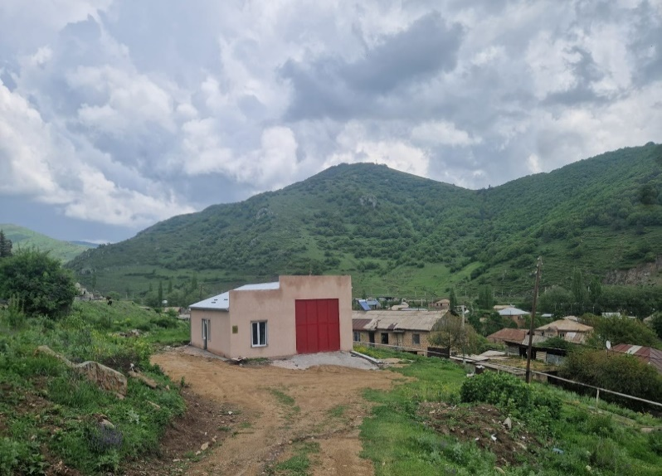  Photo #4
Local Cultural Center Children performed a Welcome Dance | Newly built Wildfire Rescue Center

